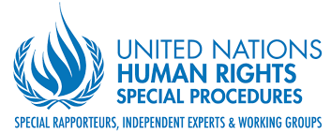
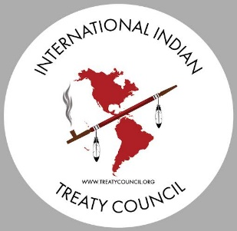

Online Consultation with United Nations Special Rapporteur on Toxics and Human Rights, Dr. Marcos Orellana, for his current Study on Toxics and the Rights of Indigenous Peoples
May 17, 18 and 19/20, 2022
General Agenda for all three Sessions:
Time | Topic and Presenter(s)
Opening  (2 minutes) | Welcome to session: Moderator Roberto Borerro, International Indian Treaty Council
Orientation to using interpretation services  (2 minutes) | One interpreter for each session language will explain how to use the zoom interpretation feature
Overview of the current Study: themes, purpose and presentation  (4 minutes) | Special Rapporteur on Toxics and Human Rights, Marcos Orellana
Background and Human Rights Framework for this Study  (4 minutes) | Toxics and the Rights of Indigenous Peoples International Indian Treaty Council (Andrea Carmen or Roberto Borrero)
Introductory comments  (4 minutes) | Special Rapporteur on the Rights of Indigenous Peoples, Francisco Cali Tzay
Framing presentations from each of the 2-3 regions highlighted in each consultation session  (5 minutes each, 25 minutes total) | 4-5 invited presenters from regions focused on in each of the three consultation sessions will highlight topics addressed in the study. These will include regional perspectives on toxic contamination from mining and extractive industries (including mercury and uranium mining), oil and gas extraction and transport, agro-chemicals, nuclear testing, and military activities, among others. Impacts on rights of Indigenous Peoples will also be addressed including on reproductive and inter-generational health, food systems, persons with disabilities, and water. International environmental treaties will be among the topics addressed, as well as shortfalls in relevant international standards.
Open discussion and presentations on the topics above  2-3 minutes each presenter, 1 hour total | All participants invited to share issues and cases impacting their Peoples addressing these or additional topics. Please use the raise hand feature. The moderator will call on each participants when it is your time to speak. Please keep to the alloted time frame of 2-3 mintues each presenter to provide opportunties for the mazimum number of speakers.
Closing observations | Special Rapporteur on Toxics and Human Rights, Marcos Orellana

Organized and hosted by
the UN Special Rapporteur on Toxics and Human Rights and the
International Indian Treaty Council

